# Task P8.1.4

It gives an following error when try to delete row from parent table.

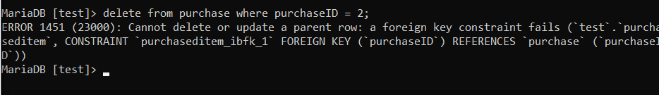

To delete such row first need to delete connected row form the child table and then delete it form parent table.

